SUNDANCE FARM MINI EVENT
PLYMOUTH, WISCONISN
SATURDAY JULY 7TH, 2018

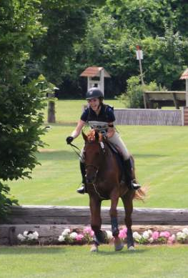

Dressage, Cross Country and Stadium Jumping all at the farm.
Opening Date: June 1st, 2018 Closing Date June 30th
Divisions Offered: Novice, BN, Starter
Ribbons thru 8th place. Limited to 50 entries.
Entry Fee: $150. Entry Forms available at www.Sundancefarm.net
Draw Checks to Sundance Farm Mini Event
Proceeds go toward purchase of new jumps for Prelim course.
Dressage: small ring on grass. Judge: Nicole Trapp
N-2018 Novice Test A, BN & Starter-2018 BN Test A
Cross Country: Course is inviting with some hills, open fields and wooded lanes.
All levels offer water, banks and ditches. No vehicles allowed on course.
All Dogs must be on Leash and under control at all times.
Very limited stabling available, contact organizer.
Negative coggins required. Payment must accompany entry.

Contact Info: Directions to venue:
Kelly Mahloch (920)918-1166 W6224 Woodland Road, Plymouth, WI
Sundancefarm1@Frontier.com

SUNDANCE FARM MINI EVENT ENTRY FORM

NAME OF RIDER _________________________________
NAME OF HORSE_________________________________
DESIRED LEVEL FOR MINI EVENT ________________
EMAIL ADDRESS _______________________________
PHONE NUMBER ________________________________
RIDER ADDRESS ________________________________
EMERGENCY CONTACT _________________________

ENTRY FEE ($150) ______ written to “Sundance Farm Mini Event”
Please remember to include copy of Current Negative coggins.
Must be dated after 7\8\2017

Very Limited Day stabling available. Must contact organizer.
Kelly Mahloch (920)918-1166 or Ali Kuhn (920) 889-9223

Mail Entries and Check to:
Sundance Farm, N6329 Branch Road, Plymouth, WI 53073

